Snake’s Painless Photoshop Ship Texturing Tutorial

*What you need
- Photoshop 5.5 or above
- Some artistic talent
- At least 20 cigarettes or yowl pull your own hair out
- A PC (with mouse and monitor)
- A dozen gallons of espresso Coffee

I assume you have already installed the relic actions and ship texturing actions ( If not read the Photoshop actions installation in RDN tools)

- Open up your texture in Photoshop.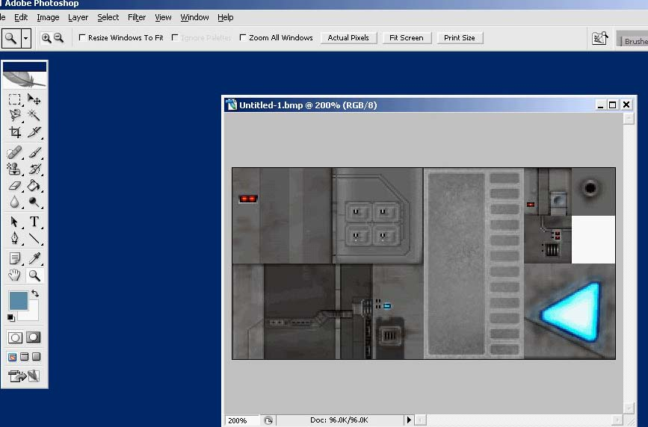
- Copy the image with the Rectangular Marquee tool and copy and past it as a new image this will be for the glow layer later on.
- Open your actions Tab and click on Desaturate to remove all the color from the
- image.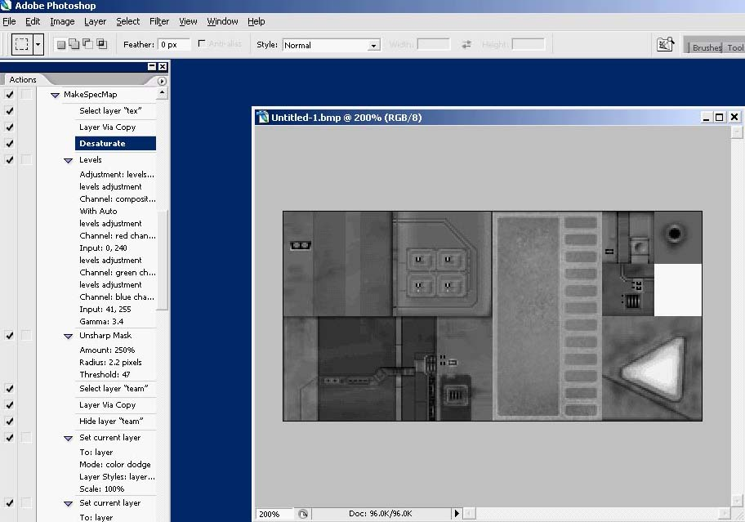
- From the Layers tab create a new layer named team ( Lower case!). Click on your color tab and click the swatches tab and make a new swatch, name it team. The color is 5d8daa or in rgb it’s R93, G141,B170.
- Now we need to select the parts of the texture to be colored with the team color. Click on layer one or background (The layer with your main image) and with either the magic wand tool (Saves Time) or the Marquee rectangular tool (For more detail) highlight the areas which you want as the team color of the texture. (To add parts hold down the shift key and to remove the Alt key). 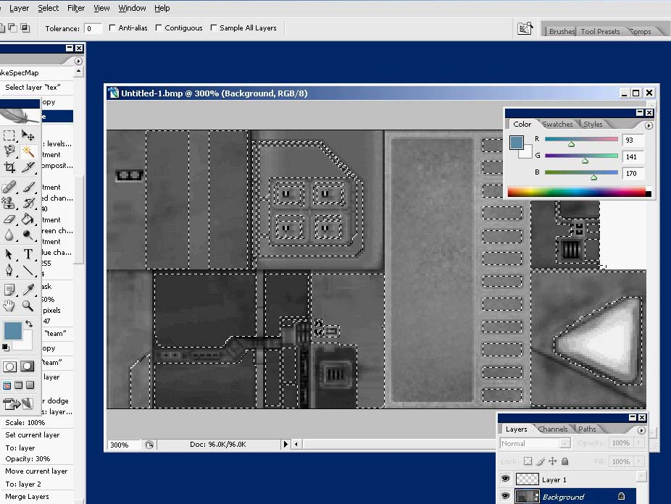
Make sure your selecting from your main background image and not the blank team layer.
Use Magic Wand for quick selection or for finer detail the Rectangle Marquee tool. You should have something like below when done
- Click on Team layer with the highlighted area still selected and then fill it using the team color. You should have something like this when done.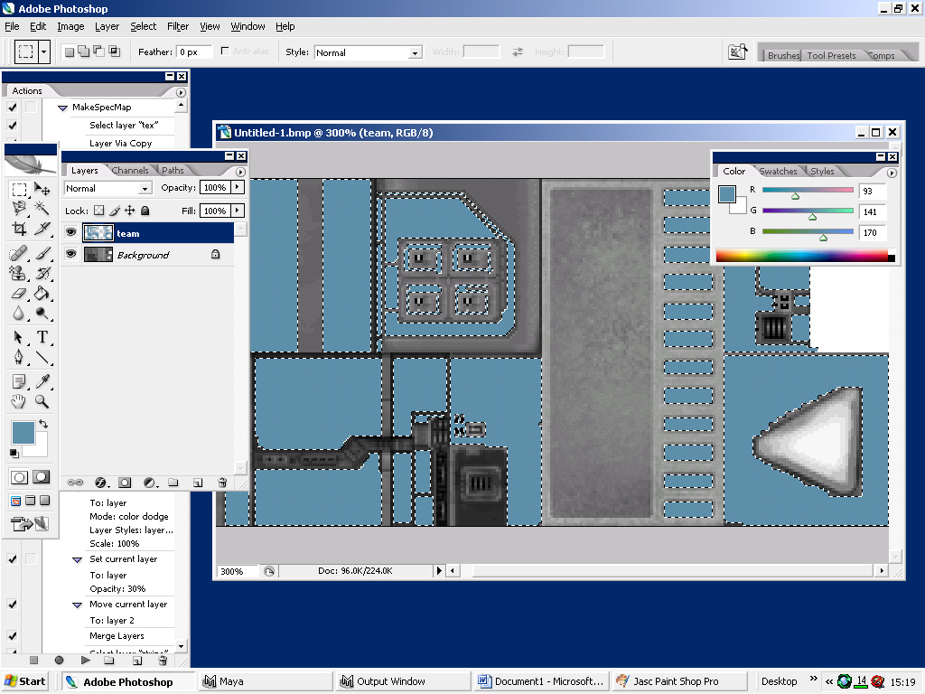
- To just verify you’ve done the team layer correct go to the actions tab and click on Select layer team. If no error message pops up all is fine if an error does pop up you’ve probably named it wrong ( Case sensitive)
- Adding the Stripe: Create a new blank layer above your team layer. Name it “stripe” (Lowercase). Go to your swatches tab and create a new swatch, name it stripe as well. Color details are “ffffff” or R255 G255 B255. The best way to do this is to have your default background and team background visible but draw onto the stripe layer ( see example below)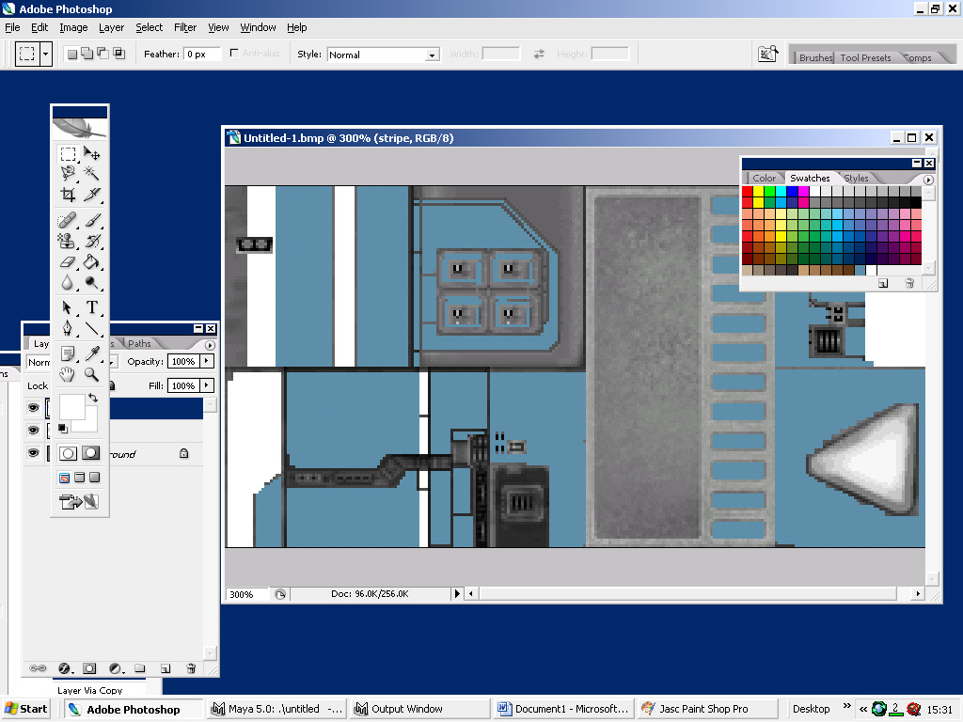
- Now merge the stripe and team layer together. Copy this layer to your other unaltered background (The one with the colors) and paste it into it. Merge the layers all together now so you have one image.
- Open up your rdn hiig_interceptor_export and erase the background image but keep the other layers for reference. Paste your background into the blank background image. You should have something like this now. 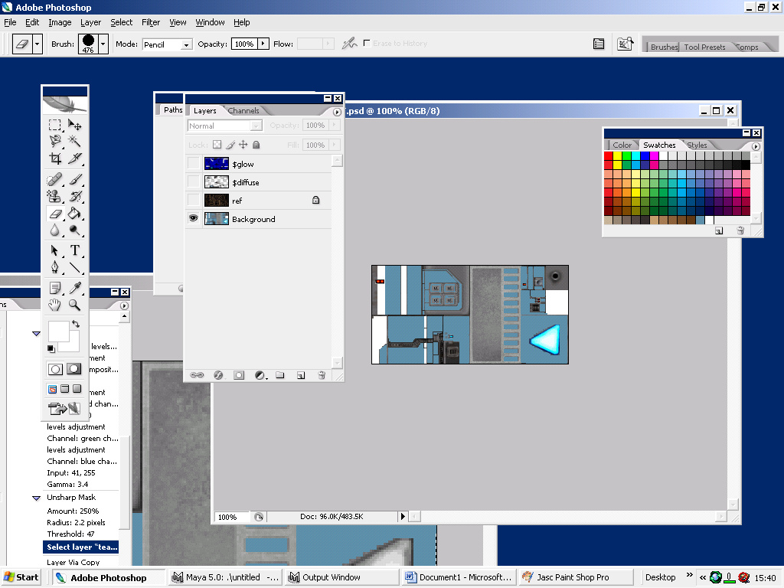
- Now we need to create the details for the texture. Open up your default background image (the unaltered texture) and with either the Rectangle Marquee tool or the Magic wand tool, highlight the areas you want to stand out on your ship.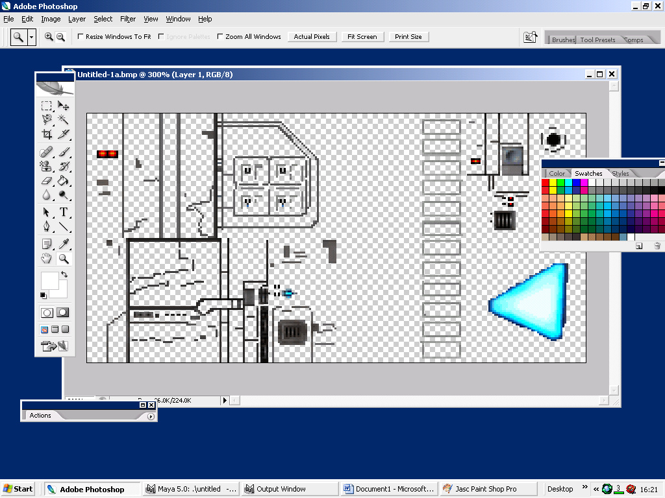
- Copy this layer. Go to your Hiig_Interceptor_Exp and delete the $diffuse Layer. Paste your details into it.
- Now for your Glow layer. Easiest way to do this layer is to copy your background layer and then from the relic actions press the Channel mixer tab, Threes a few of them but the navy blue one is the the one you want. Also remember to have where your stripe is not leveled and also your engine. On your engine highlight with the magic wand tool and I think it’s the tab below in the actions tab for green and double click that to give your engines that engine glow.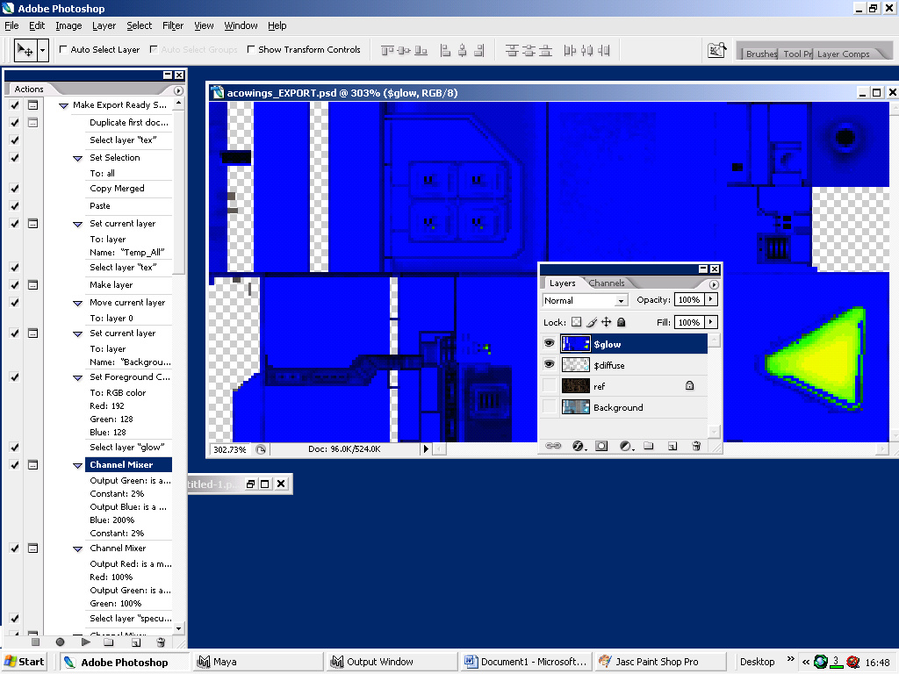
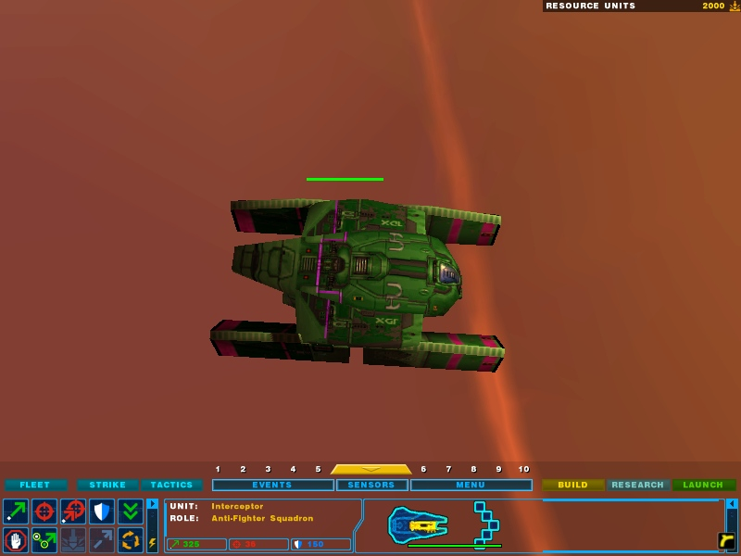
15. All done open up HW2 and check if it’s working properly. If you did it correct you end up with something similar to the pic below. I use high contrast colors to see the details so stripe is purple and team is green. The reason the colors of the strip is different on the wings is because the ships in cata had a different color on there so sort of redone that.
